Outlook 2002 Automated Installation Guide

Pre-Installation
These instructions will walk you through a complete installation of Microsoft Outlook 2002 using the automated install CD provided by the Hilton Outlook Deployment Team.
Please read through these instructions prior to installation, and contact the Outlook Deployment Team with any questions or concerns. During the installation process, should you need assistance and the instructions not cover your situation, please contact the Outlook Deployment Team, and they will be happy to assist you. You may call the Outlook Deployment Help Desk at (310) 205-4013 or send an e-mail to Outlook Deployment (or outlook_deployment@hilton.com from the internet).

- If you already have Outlook 2002 installed as part of the Office XP suite, please contact the Outlook Deployment Team for assistance with running the Profile Reset Tool.

To determine which version of Microsoft Office is installed on your computer:
- Open a Microsoft Office application such as Microsoft Word or Microsoft Excel
- Go to the Help menu and select About Microsoft Word or About Microsoft Excel. Note: Office XP programs will be listed as version 2002.

If Outlook 2002 (as part of the Office XP suite) is installed on your computer, do not re-install it or attempt to remove the installed version of Outlook! Please contact the Outlook Deployment Team (using the contact information above) for further assistance.

- This installation will take up space on your “C:” hard drive. Please ensure that you have at least 200 MB of free space on that drive.

- Be sure all programs are shut down (including the MS Office toolbar) and all virus-scanning tools are turned off before inserting the Outlook 2002 CD.

System 21 Properties Only: Copying Install Software to the Server

- The first time the install CD is inserted into your System 21 workstation, the CD will automatically copy itself to the install area on your System 21 Server.

- This process provides the Hilton Support Center the ability to assist you with reconfiguring or re-installing Outlook in the future.

- This process may take anywhere from 5 to 45 minutes to complete. Please be patient, and do not interrupt the copy process.

- At the end of the copy process, you will be given the option to run the client installation.

- Subsequent times the CD is inserted into a System 21 workstation, the CD will immediately give you the option to run the client installation.

Installing the Software
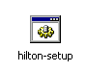
- Insert the CD and let it “auto-run”, or run hilton-setup.bat (it may appear to be named simply “Hilton-setup”) if the installation doesn’t start automatically.

If you are installing from the server have them go to X:\Outlook folder and run the Hilton-setup.bat
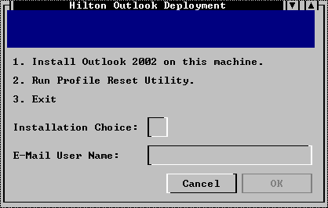
- A menu will appear. Select the Install Outlook 2002 on this machine option by typing the number “1”.

- In the E-Mail User Name field, enter the email user name for the email account to access on this computer. Note: The user name is the name you would normally use (after “hotels\”) when logging in to Outlook Web Access (i.e. hotels\username). Select OK.

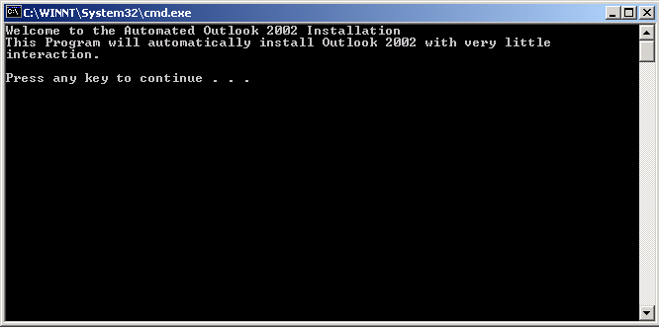
- A series of text windows will appear. Please read all of the information each one contains before continuing to the next.

- You can press the [x] button in the upper right hand corner of the window at any time during these prompts to interrupt the installation process (which you may re-start at any time).

- 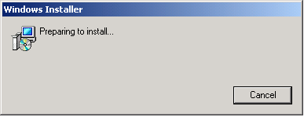Once the dialogue portion is complete, the active portion of the setup will begin. At this point, an installation progress screen will appear. (Note; the previous “character based” dialogue window will not close on its own. Unless you are aborting the installation process do not close it yourself at this point.)
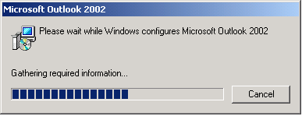

- Wait . . .

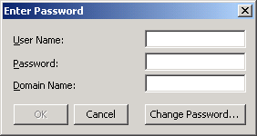
- Outlook 2002 will be automatically started, and will setup the profile. A screen will appear asking for information to log you in to the Exchange system. Your “User Name” is the name you would normally use (after “hotels\”) when logging in to Outlook Web Access (i.e. hotels\username). Your “Password” is the same password you normally use when accessing your account via Outlook Web Access. Your “Domain Name” is “hotels”.

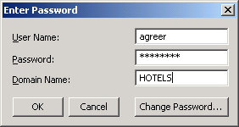
- In the example pictured, the user Aaron normally logs on to Outlook Web Access as hotels\agreer. He enters “agreer” here in the “User Name” text box, his normal password in the “Password” text box, and “hotels” in the “Domain Name” text box. Press the [OK] button to continue. Note: You will encounter a similar screen each time you log in to Outlook 2002, but will not have to re-configure a profile each time.

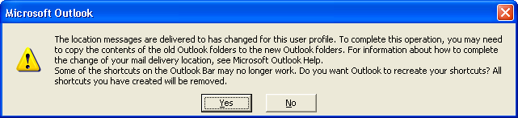
- If you are replacing a previous installation of Outlook, you may receive a prompt asking you if you want to re-create shortcuts on your Outlook shortcut bar. Click on the [Yes] button to continue.

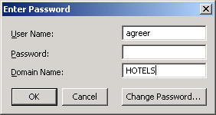
- Upon this initial configuration, but not upon subsequent logins with Outlook 2002, you may be prompted to re-enter your password. Enter the same password you entered in the previous step, then press the [OK] button to complete this process. Outlook 2002 will now open.

Configuring Views
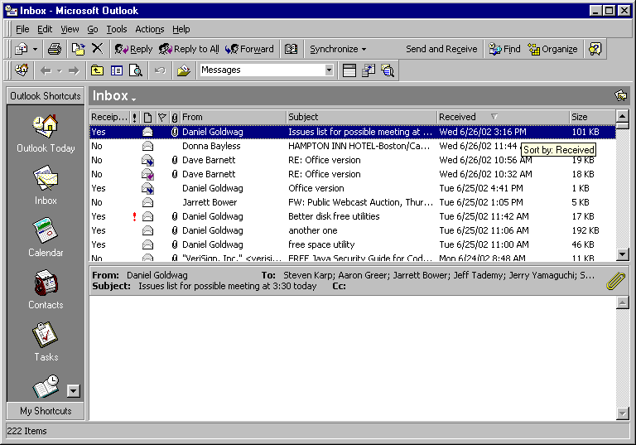

- At this point Microsoft Outlook will open and you will see your mailbox. We will make a few modifications to customize your user interface. If your view appears different than the one pictured, you may not need to make all of the following modifications.

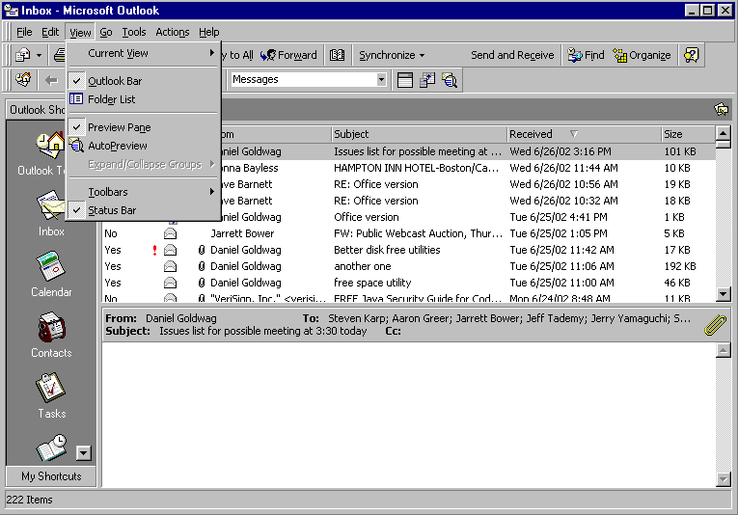

- Access the “View” drop-down menu. Un-select the “Outlook Bar” and “Preview Pane” options. Select the “Folder List” option.

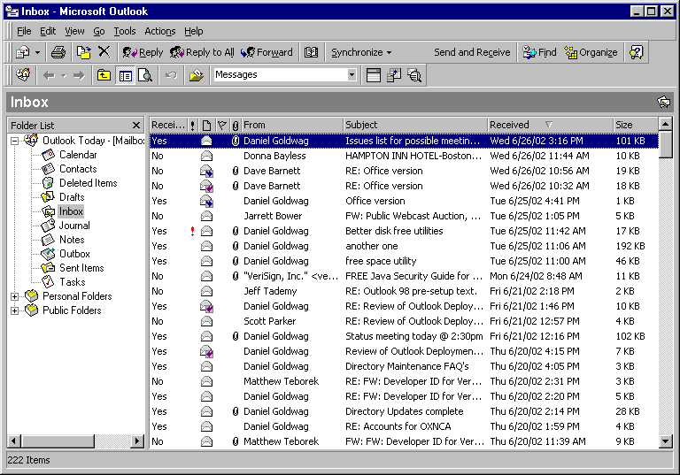

- The resultant view should be much more like the Outlook Web Access interface, and give you easy access to your deleted and sent items. Also, the elimination of the preview pane will reduce risk from newer computer viruses.

